Practice 2

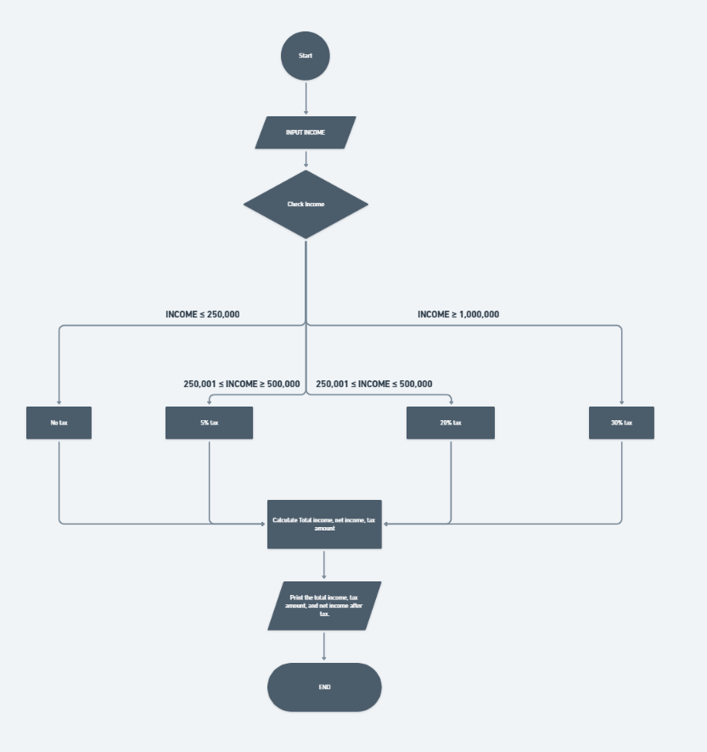

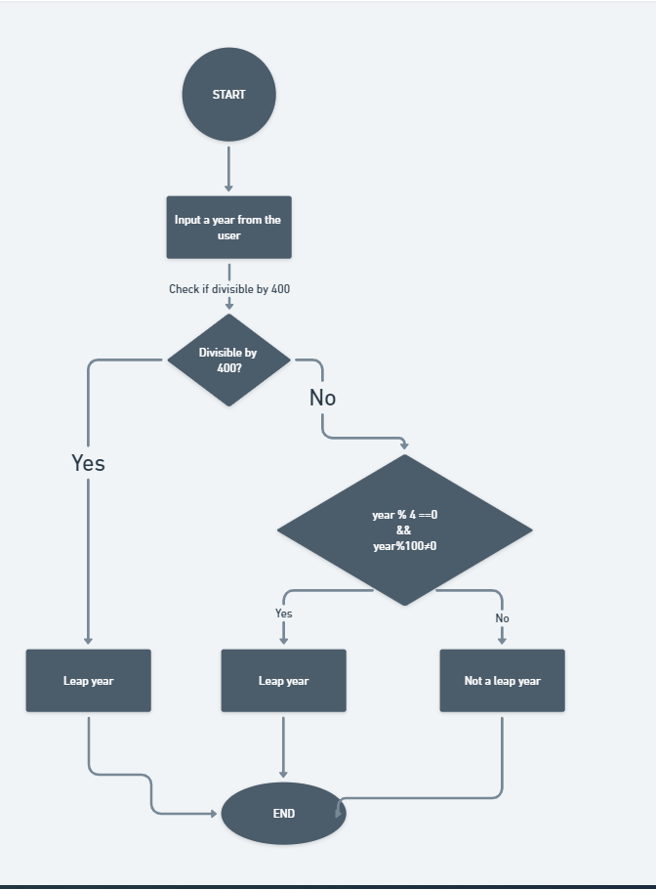practice 3

practice 4

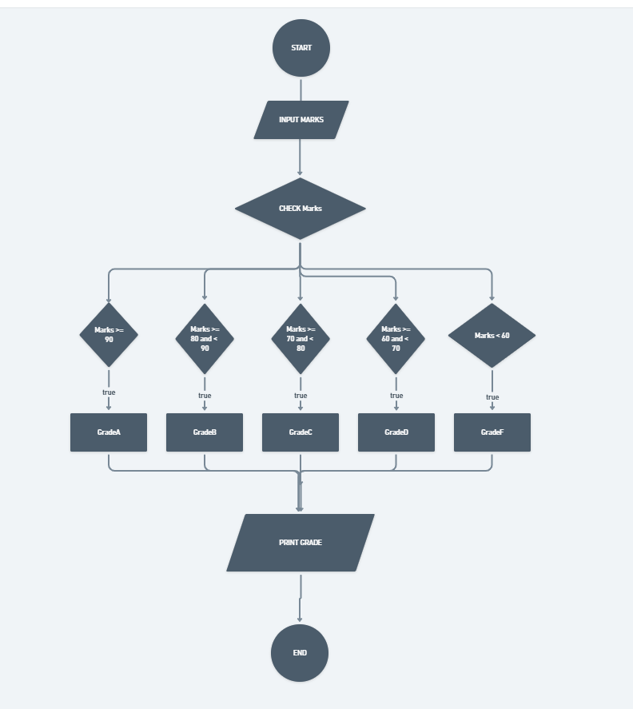

practice 1

End

The alphabet is a consonant

The alphabet is a vowel

C==’I’;

The alphabet is a vowel

C==’I’;

The alphabet is a vowel

C==’e’

The alphabet is a vowel

C==’a;

alphabet

START